

Mohd. Razia Alangir Banu
D.VENKAT SAI

2520090034
CSIT
CO-5

Case Study Topic: Meesho – Product Sales Data Sorting & Performance Analysis System
Work Done Summary:
Meesho processes millions of product records, customer orders, and sales transactions every day. Efficient sorting techniques are required to organize products based on sales, ratings, prices, and demand. Merge Sort is used for stable sorting of large datasets, while Quick Sort utilizes different pivot strategies for fast average-case performance. Heap Sort is implemented for priority-based product ranking. Counting Sort and Radix Sort are used for sorting large numerical datasets such as Product IDs and transaction records. Performance benchmarking is conducted to compare execution time, memory usage, stability, and scalability of different sorting algorithms.
Implementation Details:
- Product records such as Product ID, price, rating, and sales count are stored in arrays.
- Merge Sort is implemented for stable sorting of large product datasets.
- Quick Sort is used with different pivot selection strategies for efficient partitioning.
- Heap Sort is applied for ranking top-selling and high-priority products.
- Counting Sort and Radix Sort are used for integer-based sorting operations.
- Algorithm performance is evaluated based on time complexity, space usage, stability, and execution speed.
Output:

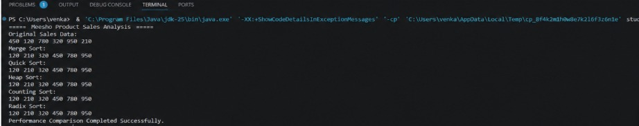

The Meesho sales analytics system demonstrates how advanced sorting algorithms efficiently organize large datasets. Benchmarking results show trade-offs among execution speed, memory consumption, stability, and scalability, helping select the most suitable sorting technique for different business scenarios.

Github link: https://github.com/Venkat-267-byte/DSA-II

